Validation:

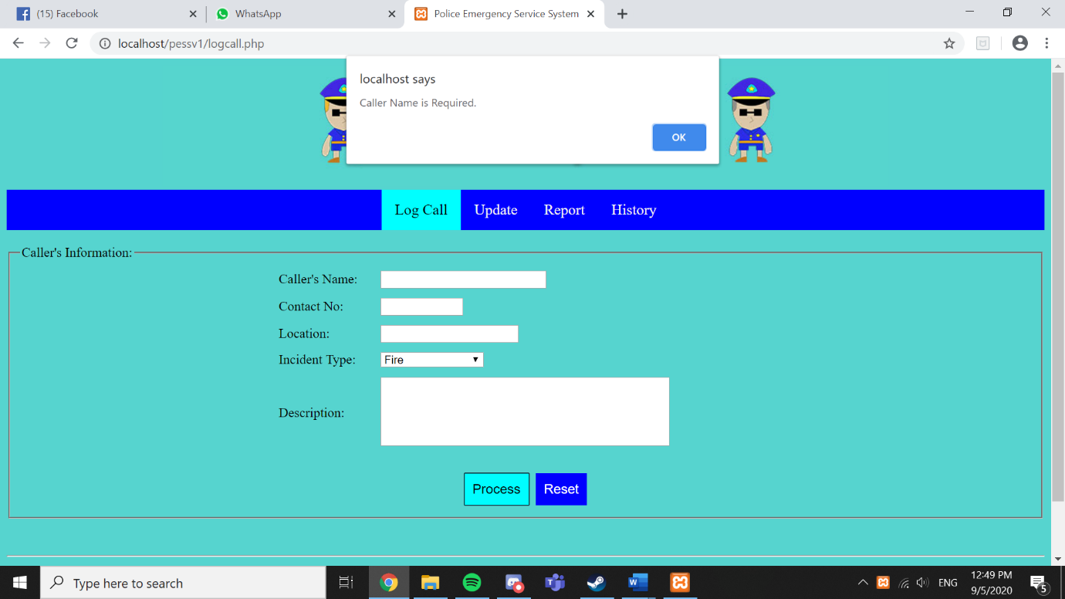When user do not enter anything in caller name:

When User enter number on caller’s name:

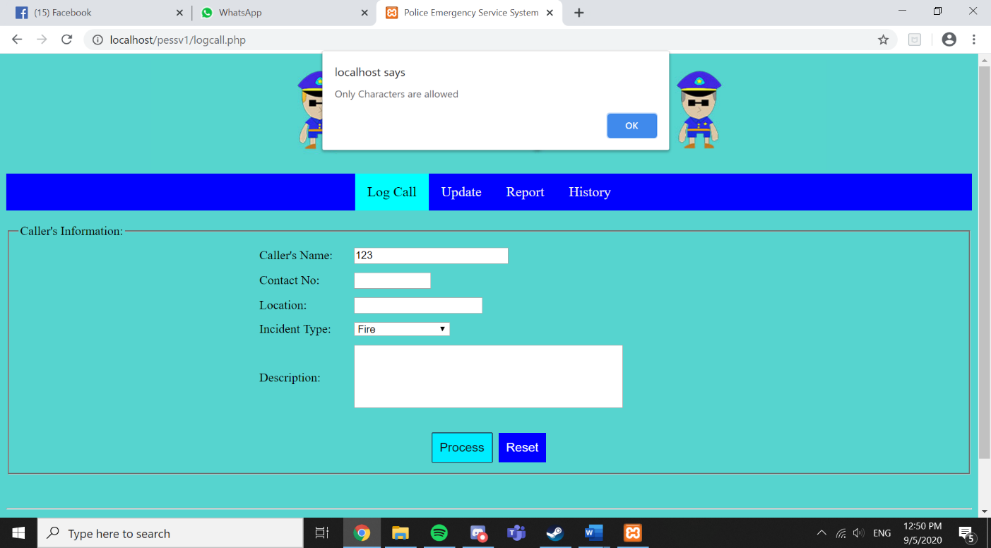

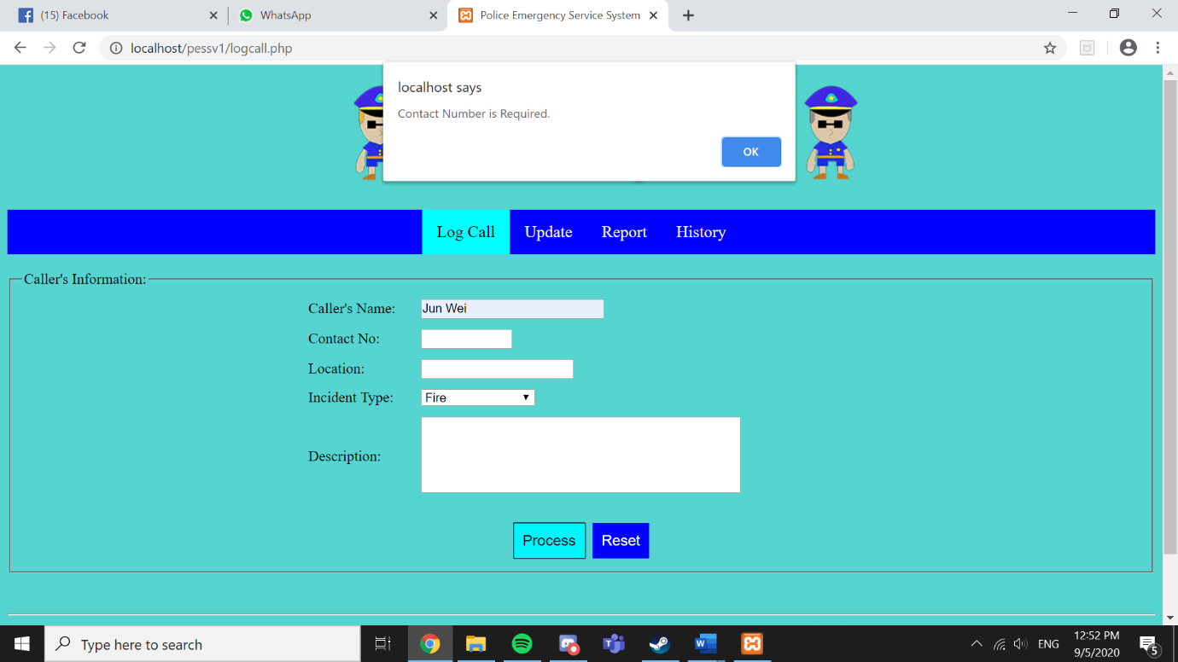When user do not enter anything for Contact Number:

When user enter alphabet instead of numbers:

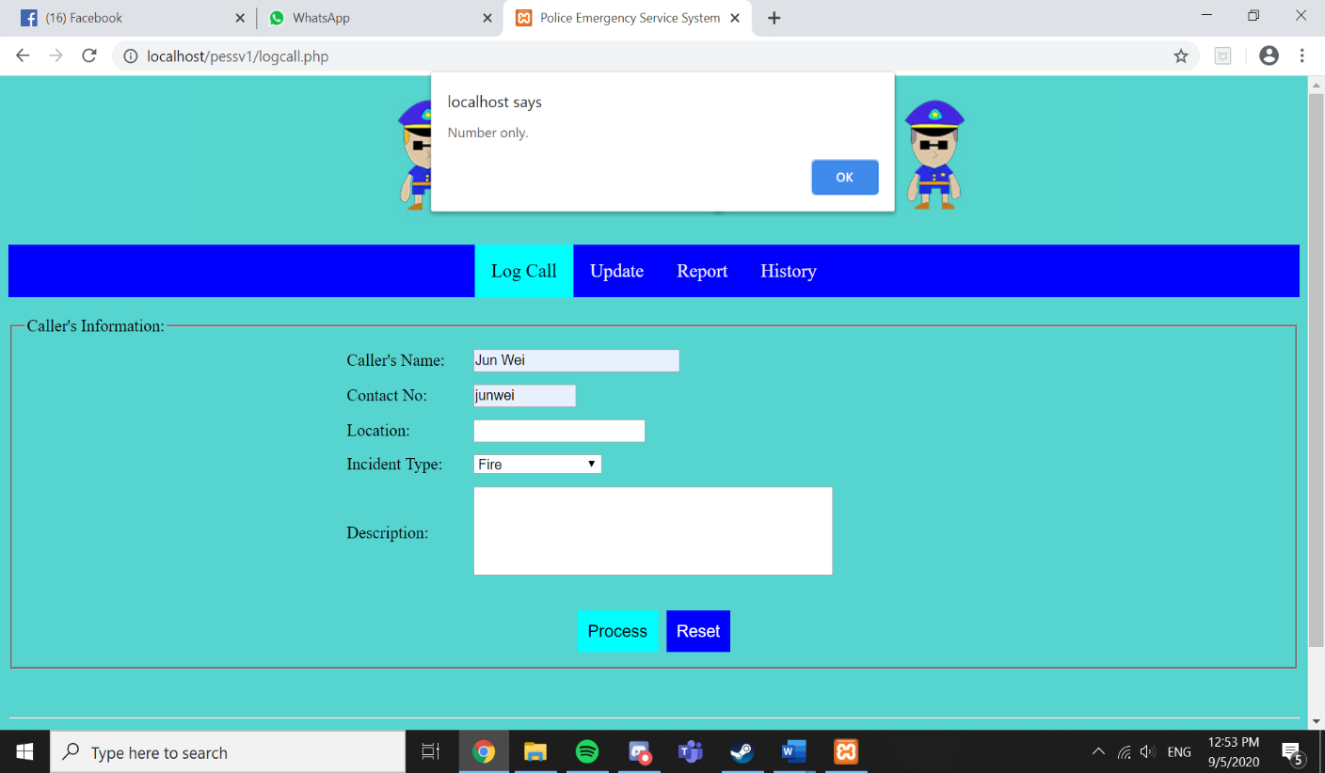

When user do not enter location:

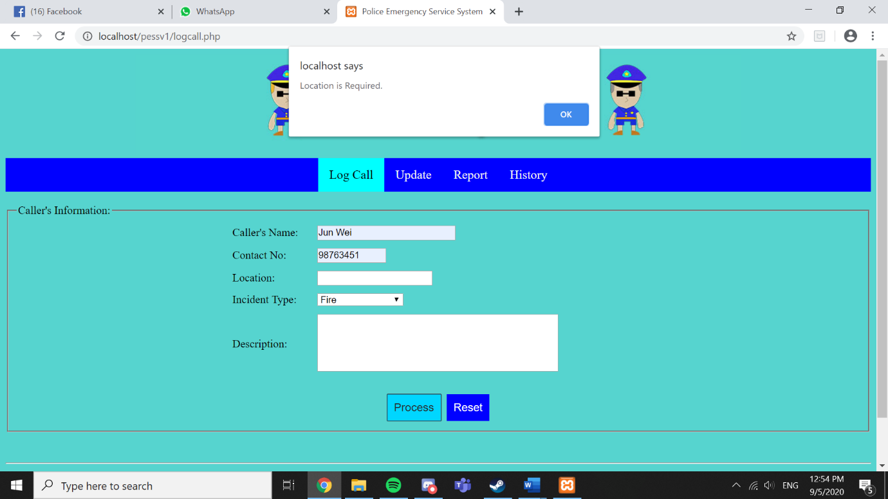

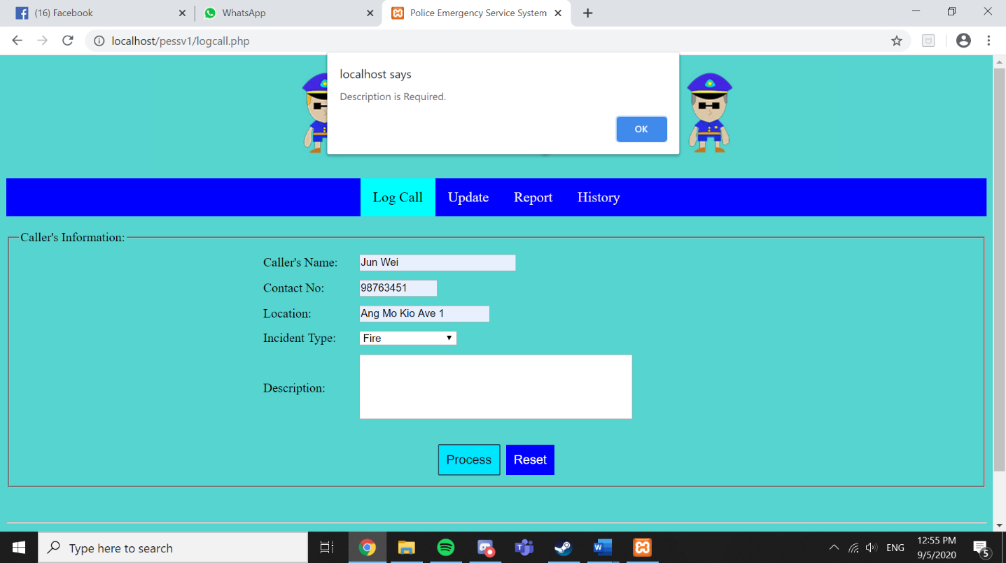When user do not enter description:

Enter This Information and screenshot:

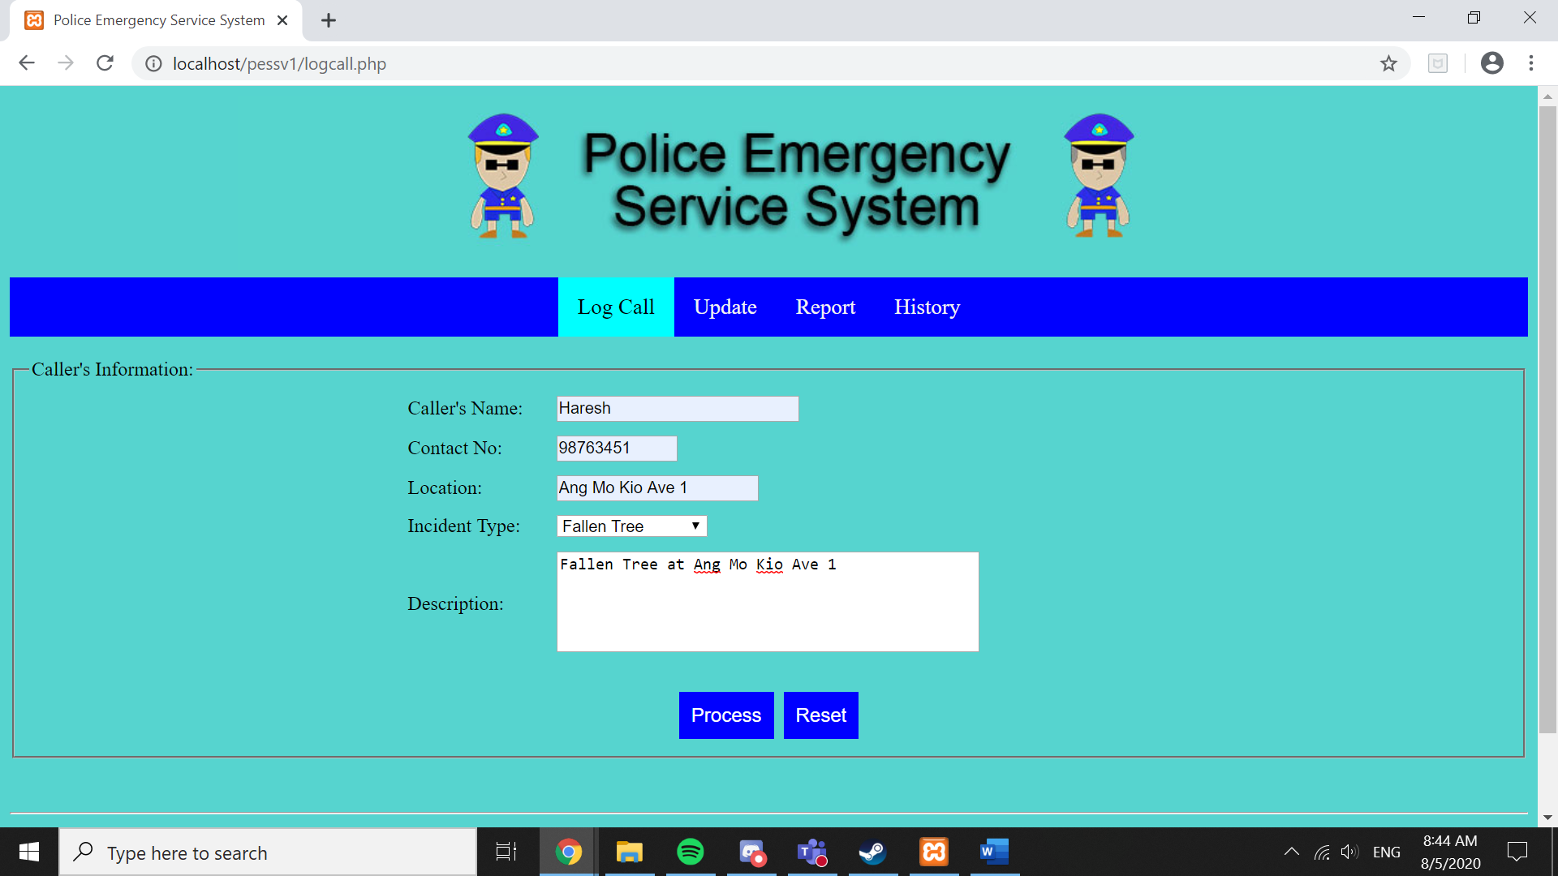

Screenshot this before tick the checkbox:

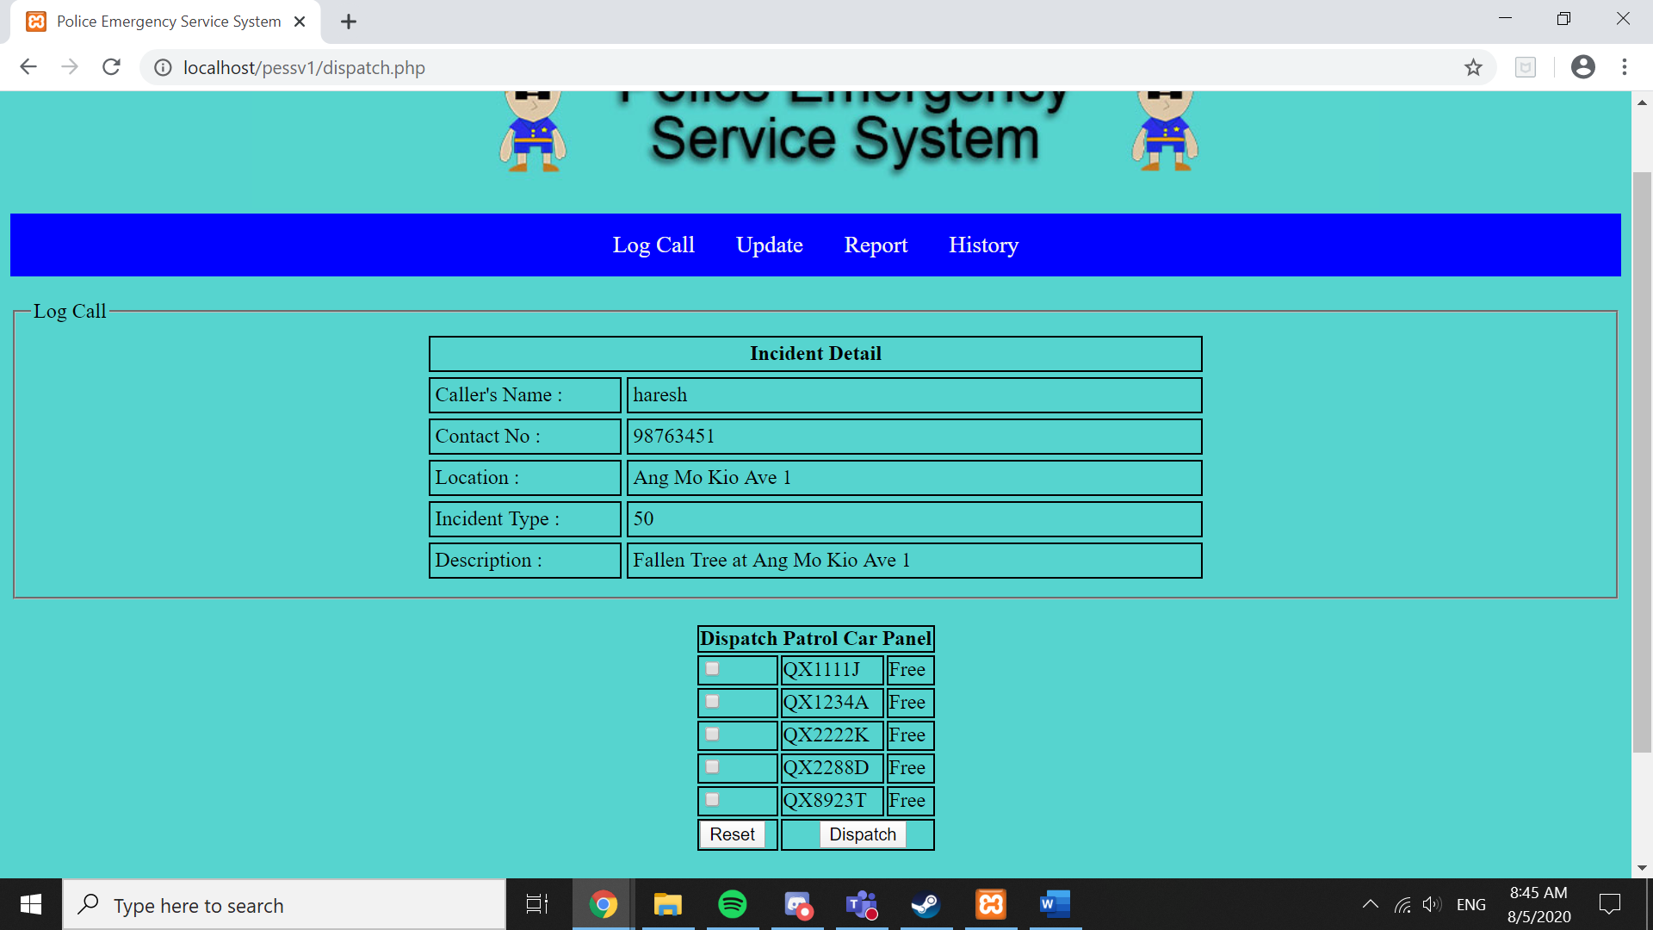

Dispatch Any Patrol Car, tick on the checkbox and screenshot:

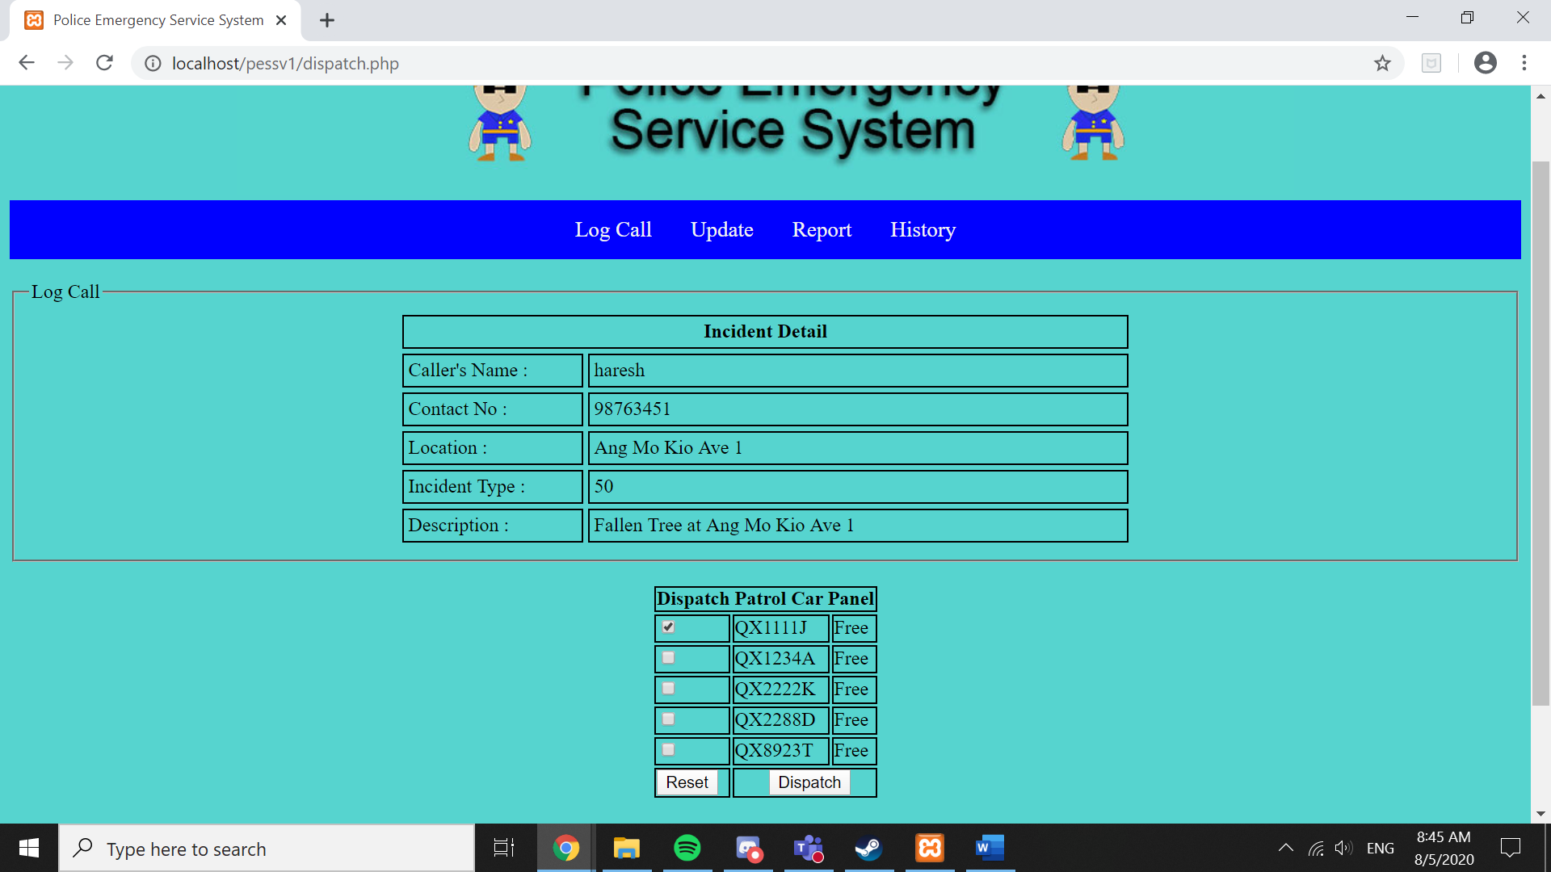

QX1111J being dispatched and disappear from the table:

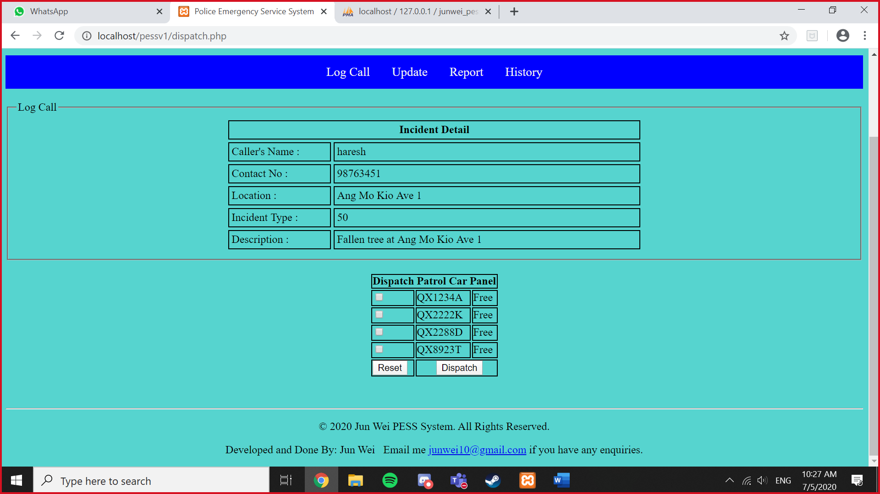

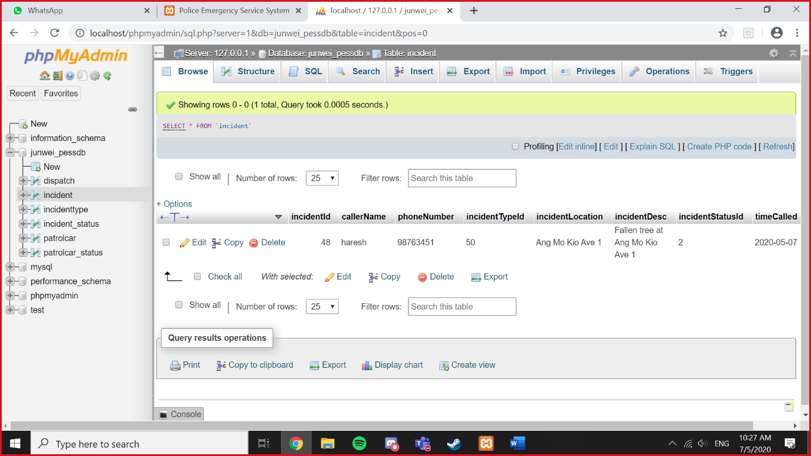Caller’s Information appear in database from incident:

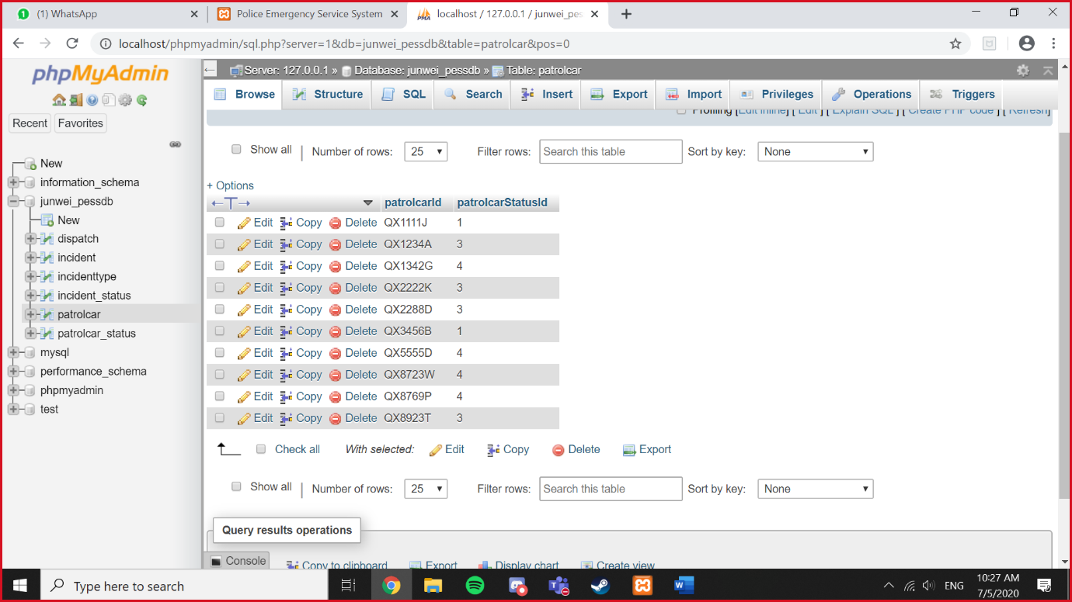Check if QX1111J patrolcarStatusId is “1”

Check if the QX1111J timedispatched timing and the date is appearing in database:

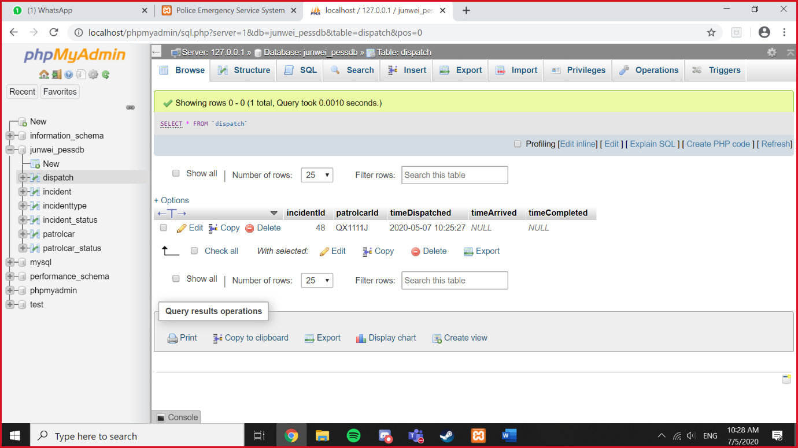

Type QX1111J and screenshot this before you search

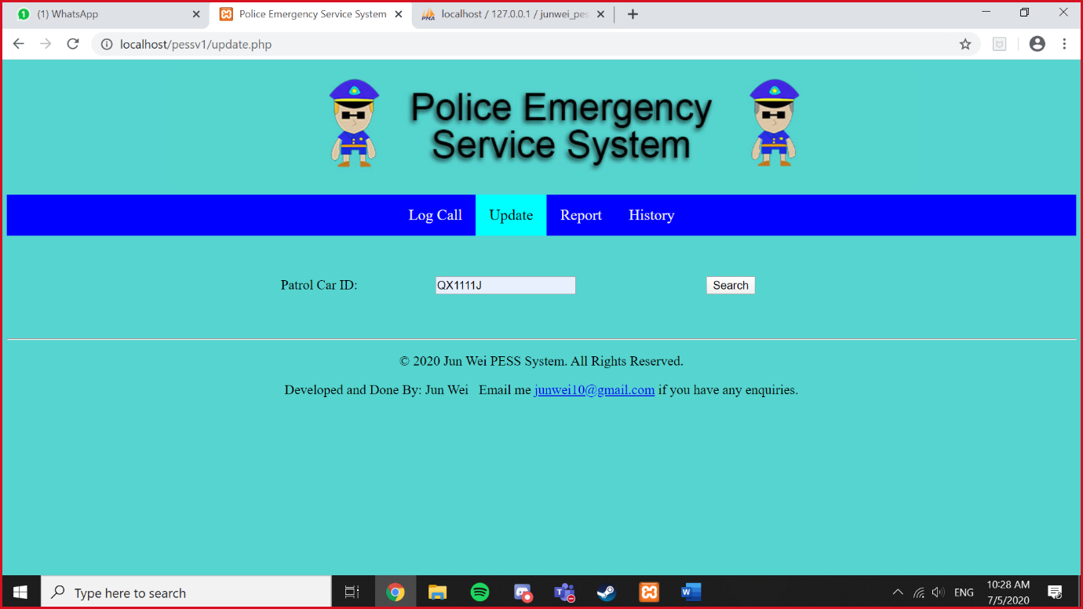

Screenshot this before you change anything

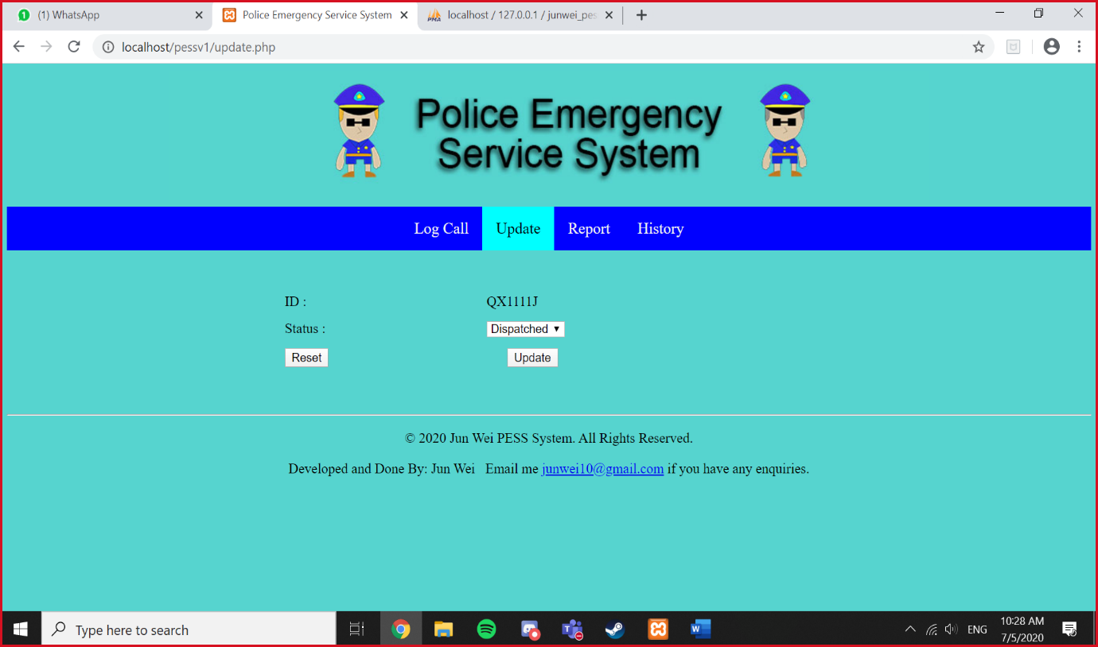

Change to Arrived and Screenshot this:

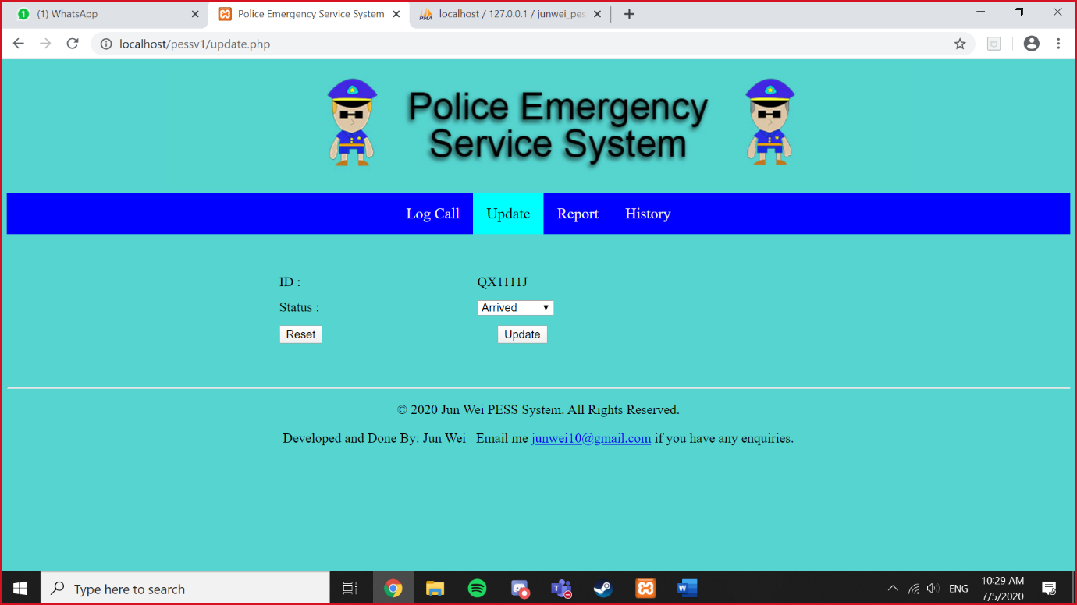

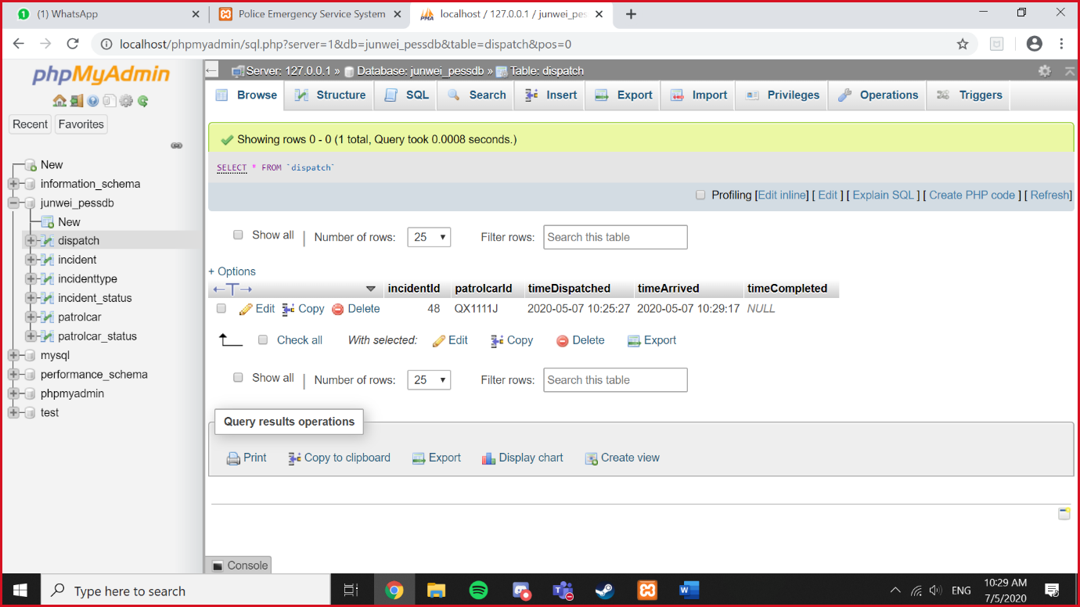Go to dispatch and check the timeArrived timing and date appear here

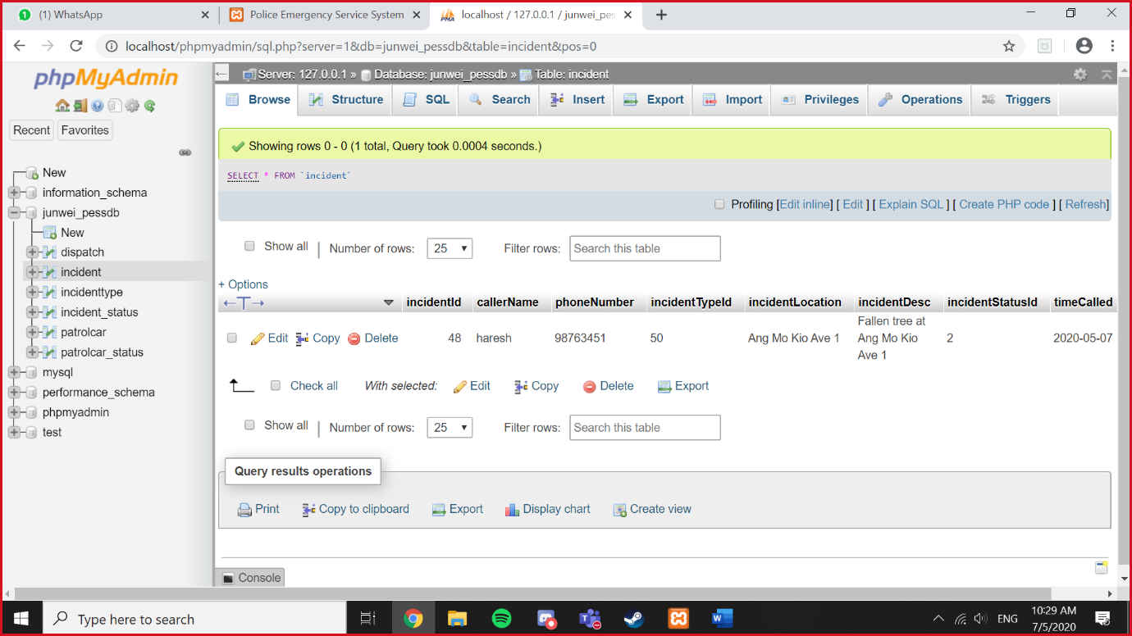Screenshot This:

Check if the QX1111J patrolcarStatusId is 4 (Arrived)

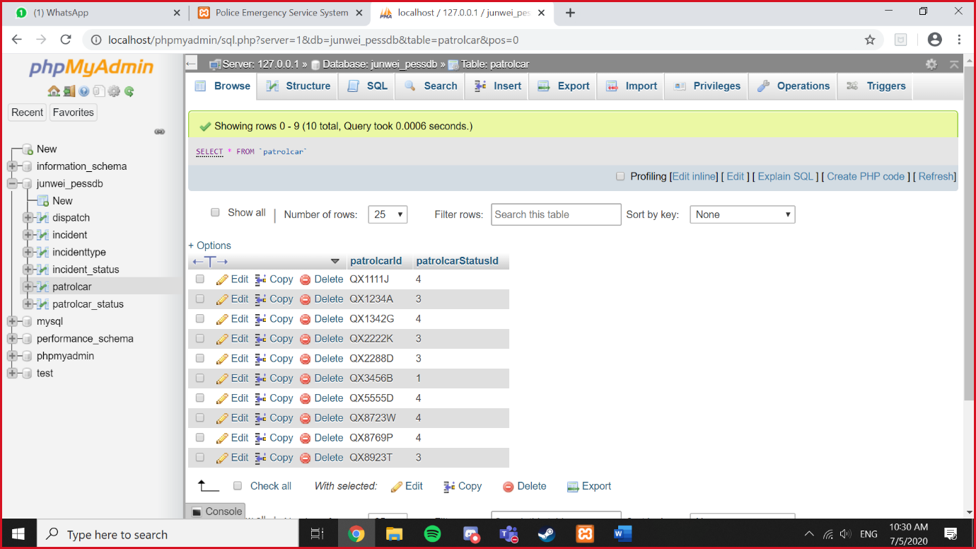

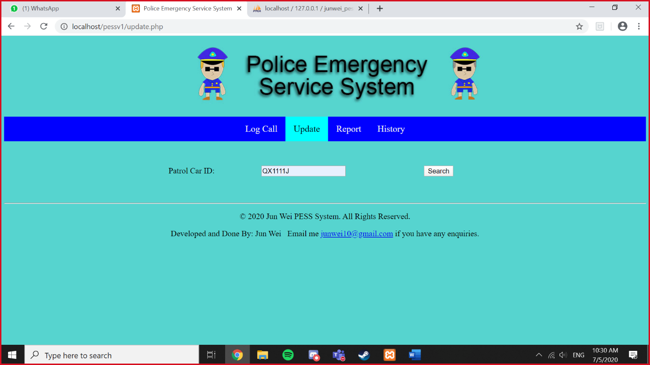Type QX1111J and screenshot

Screenshot This before you change anything:

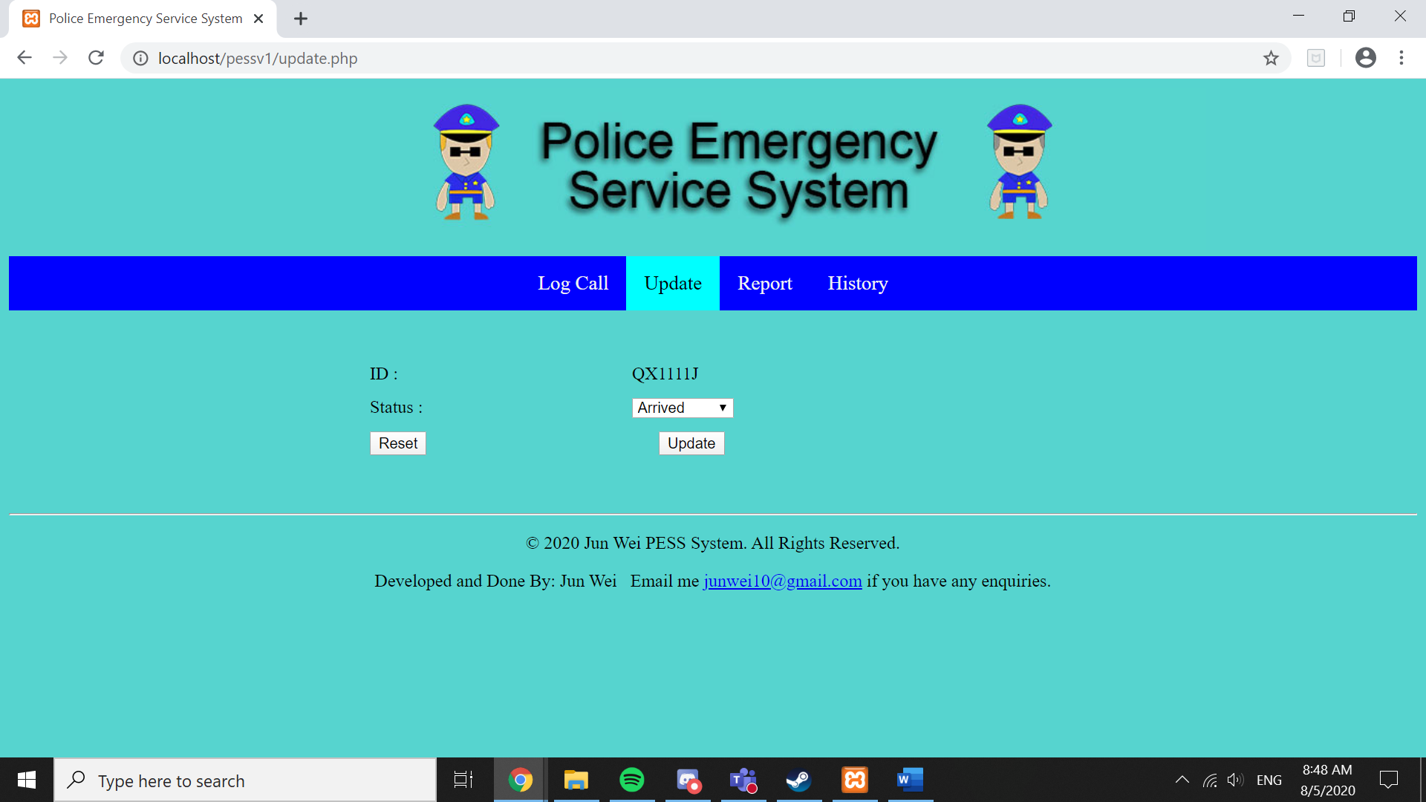

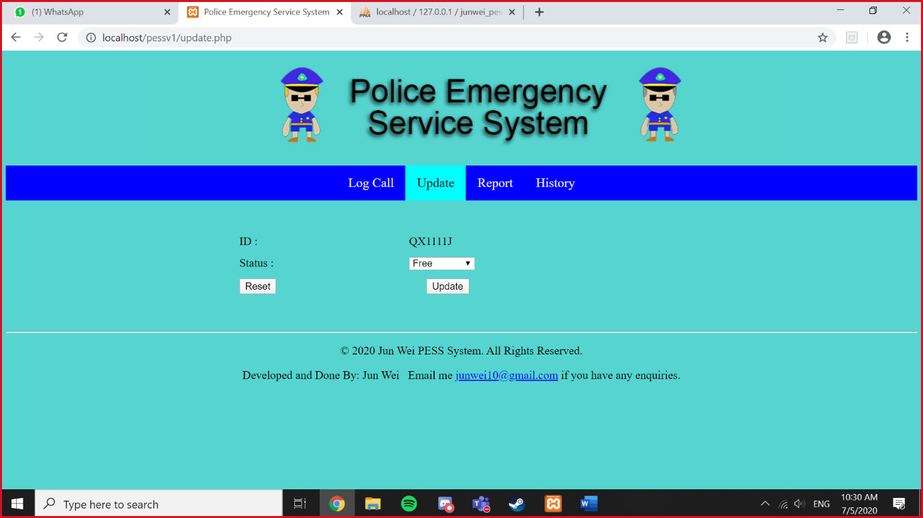Change the status to Free and screenshot:

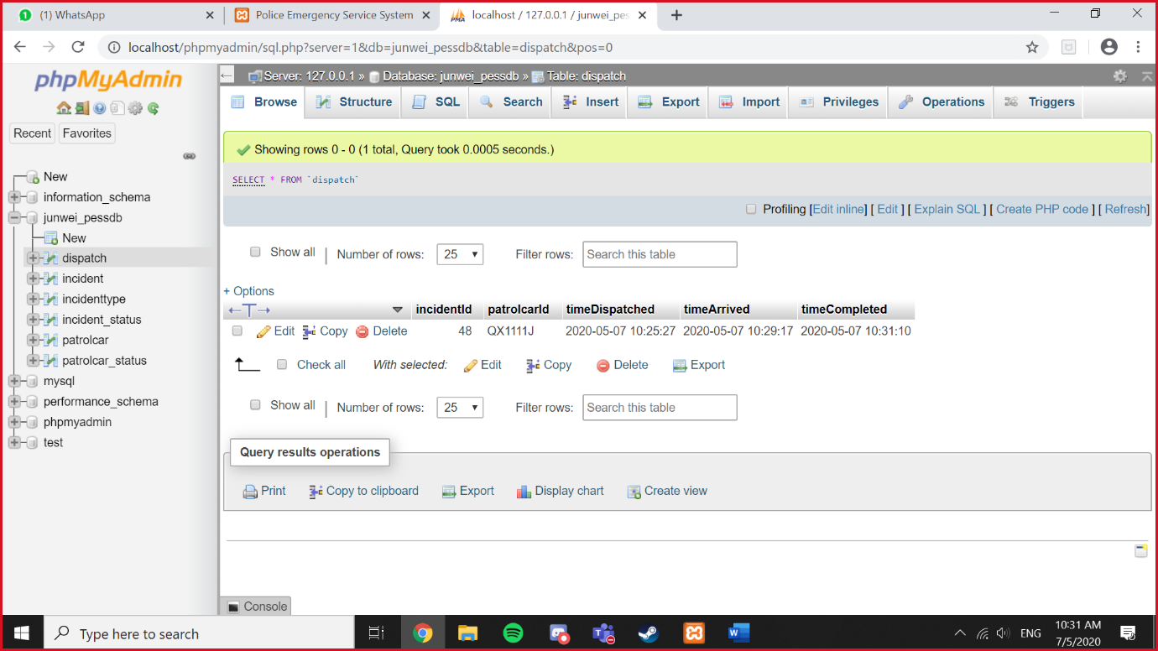Check your dispatch if the timeCompleted timing and date is appearing

Check if your QX1111J patrolcarStatusId is “3” (Free)

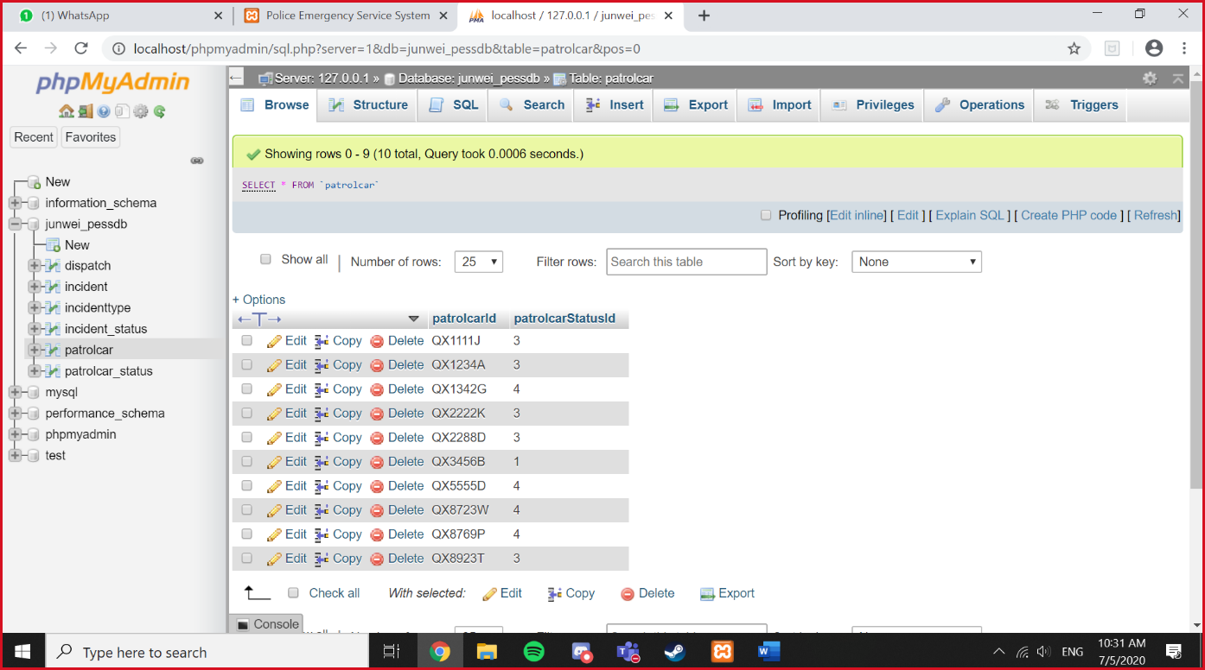

Screenshot this file location:

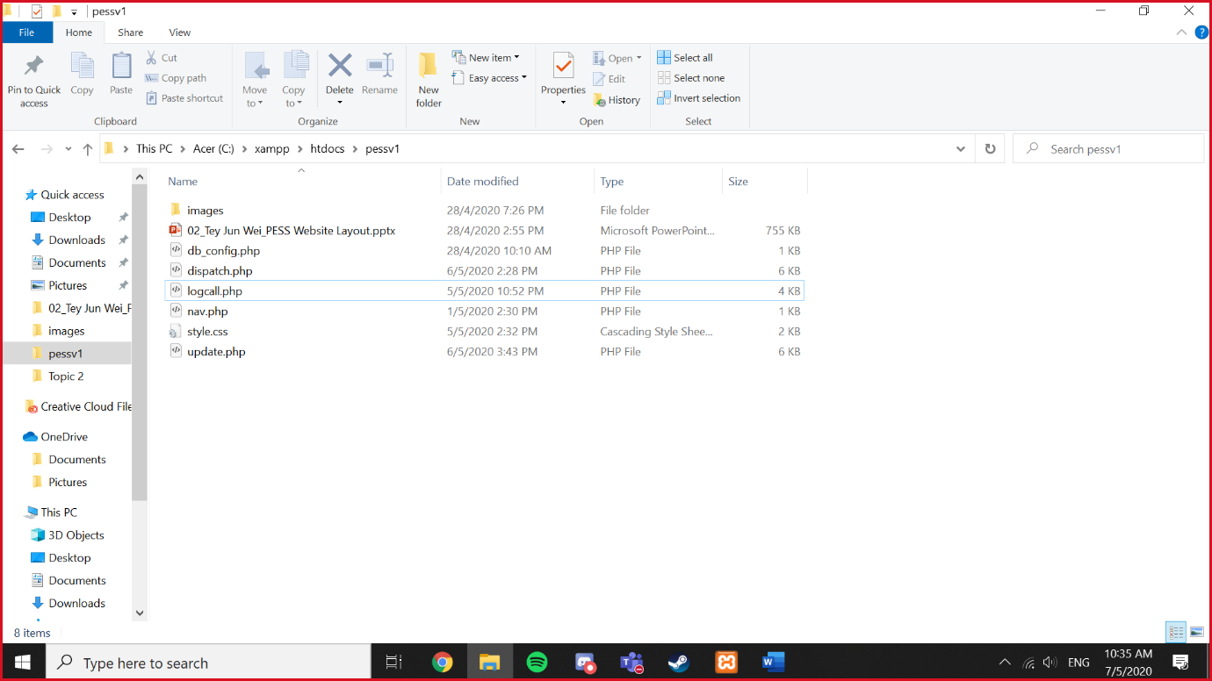

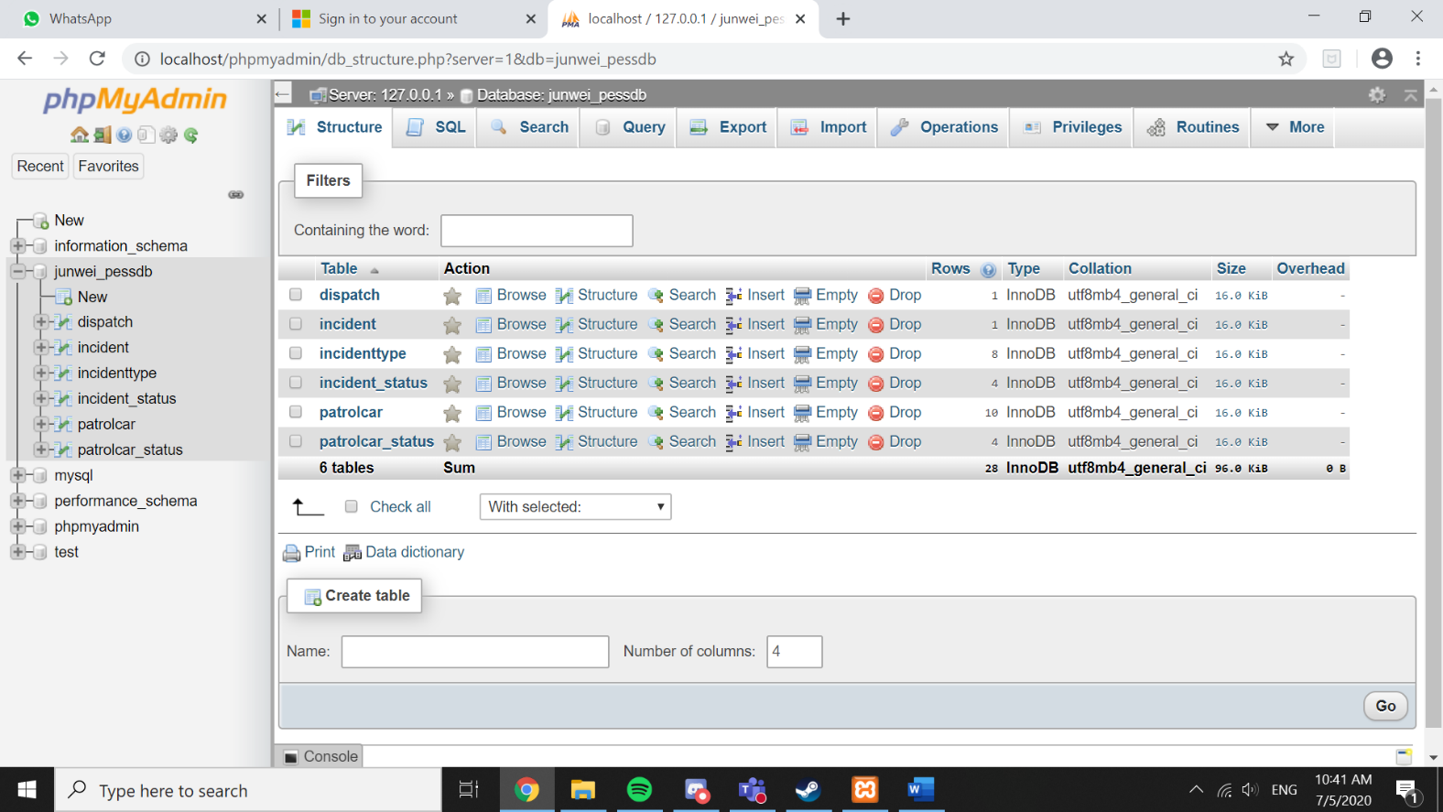Screenshot yourname_pessdb structure:

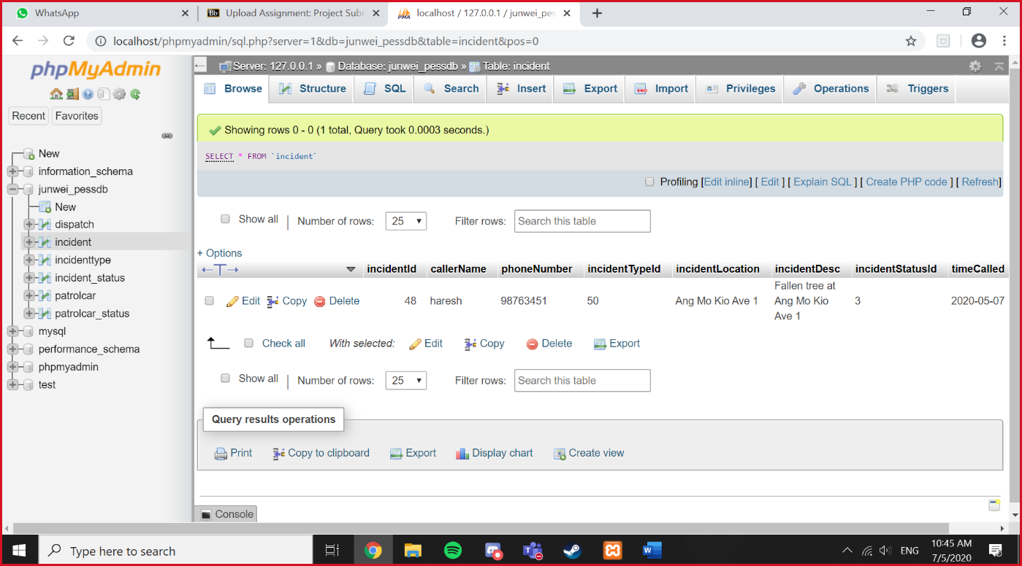Screenshot dispatch browse:

Screenshot dispatch structure:

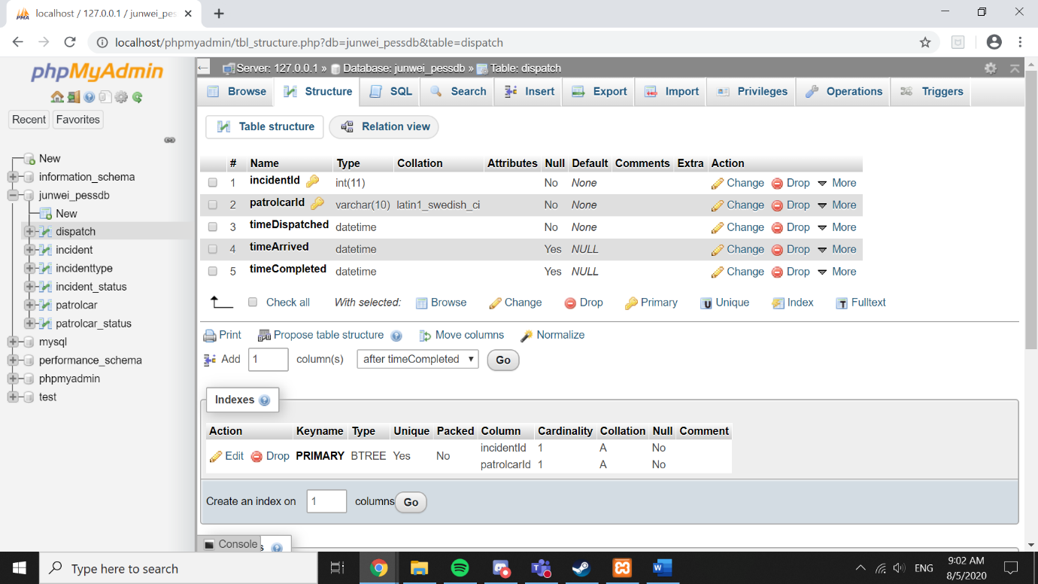

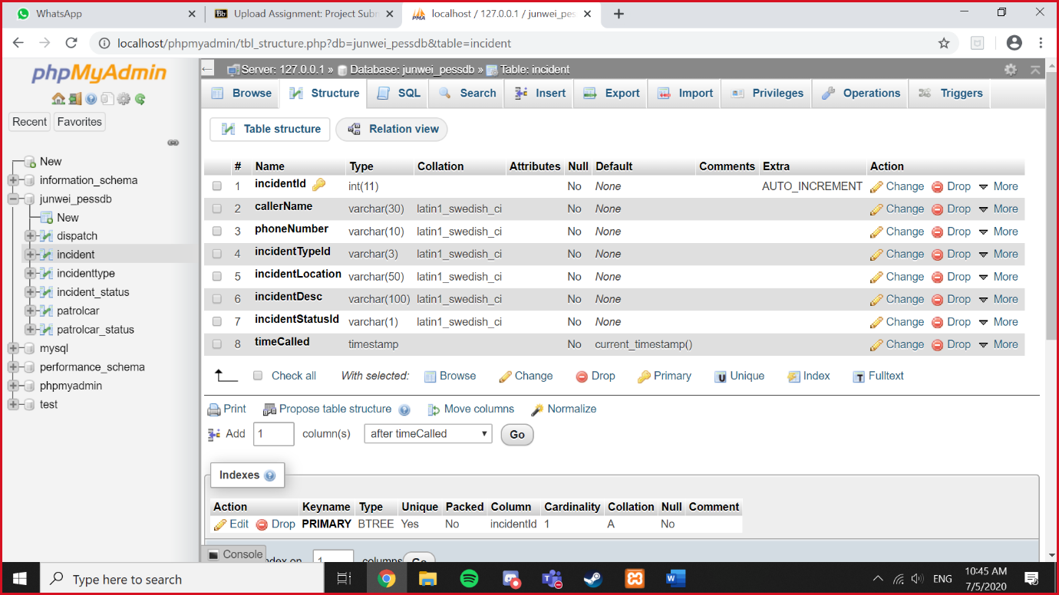Screenshot incident structure:

Screenshot incidenttype browse:

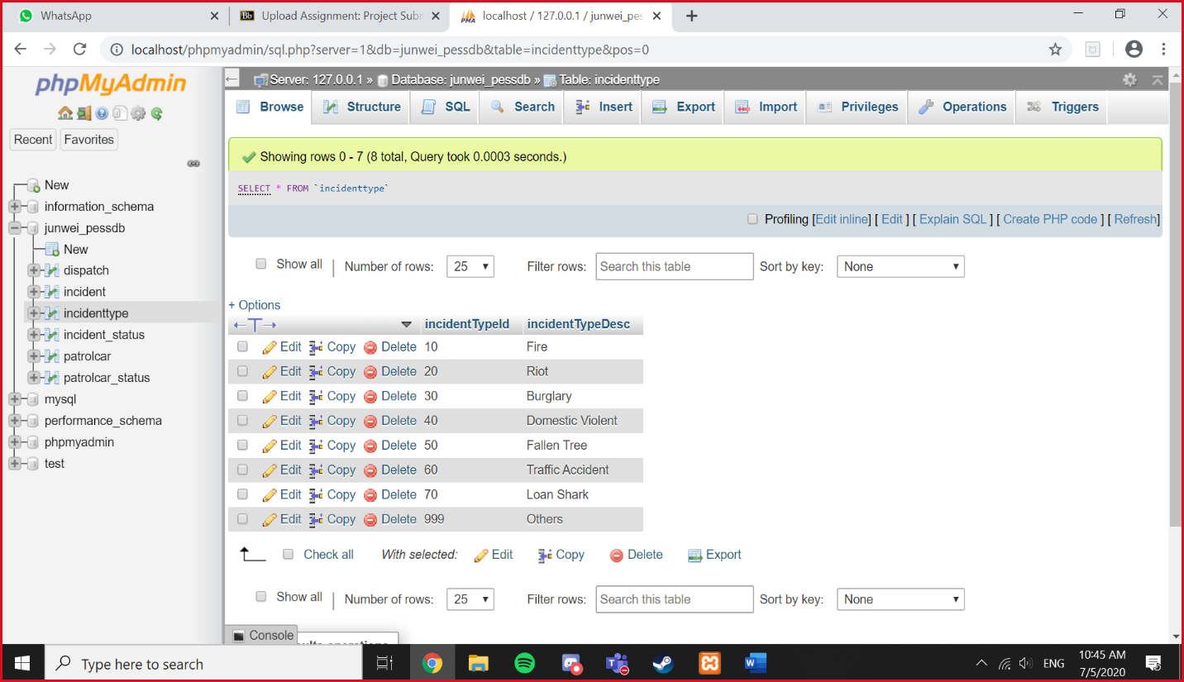

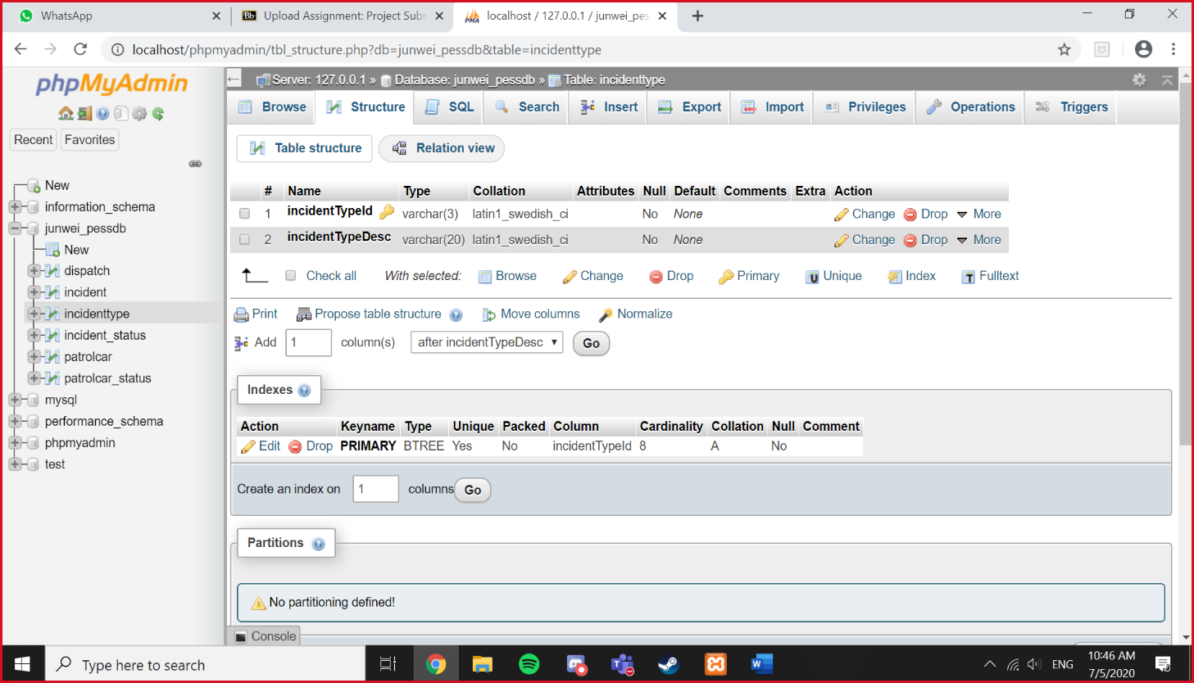Screenshot incidenttype structure:

Screenshot incident_status browse:

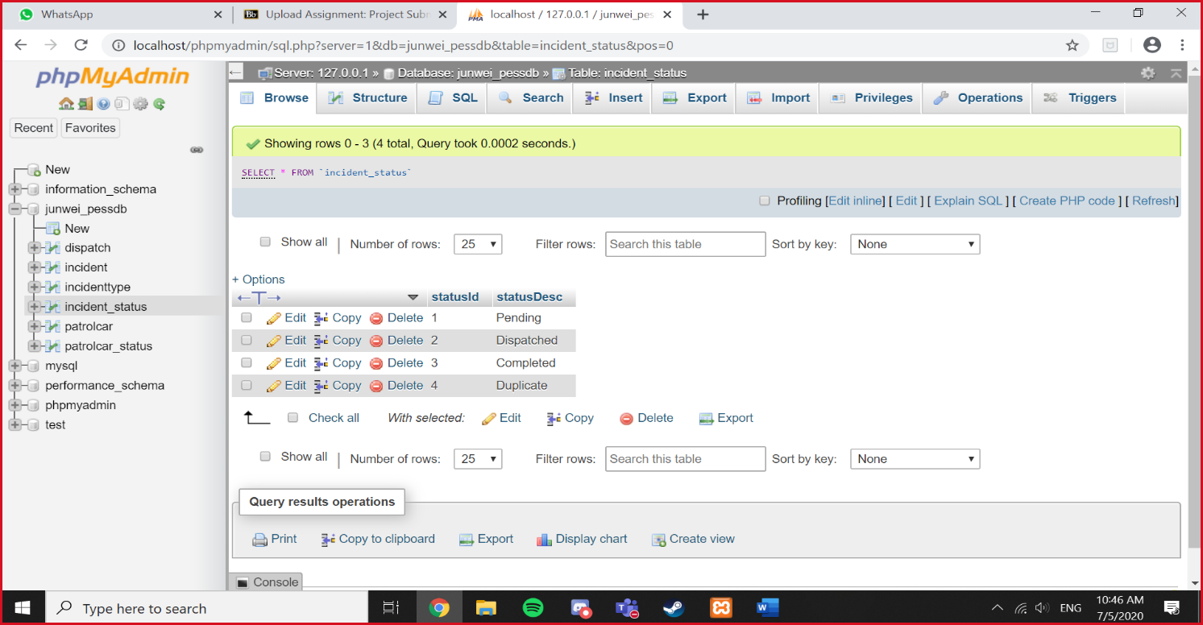

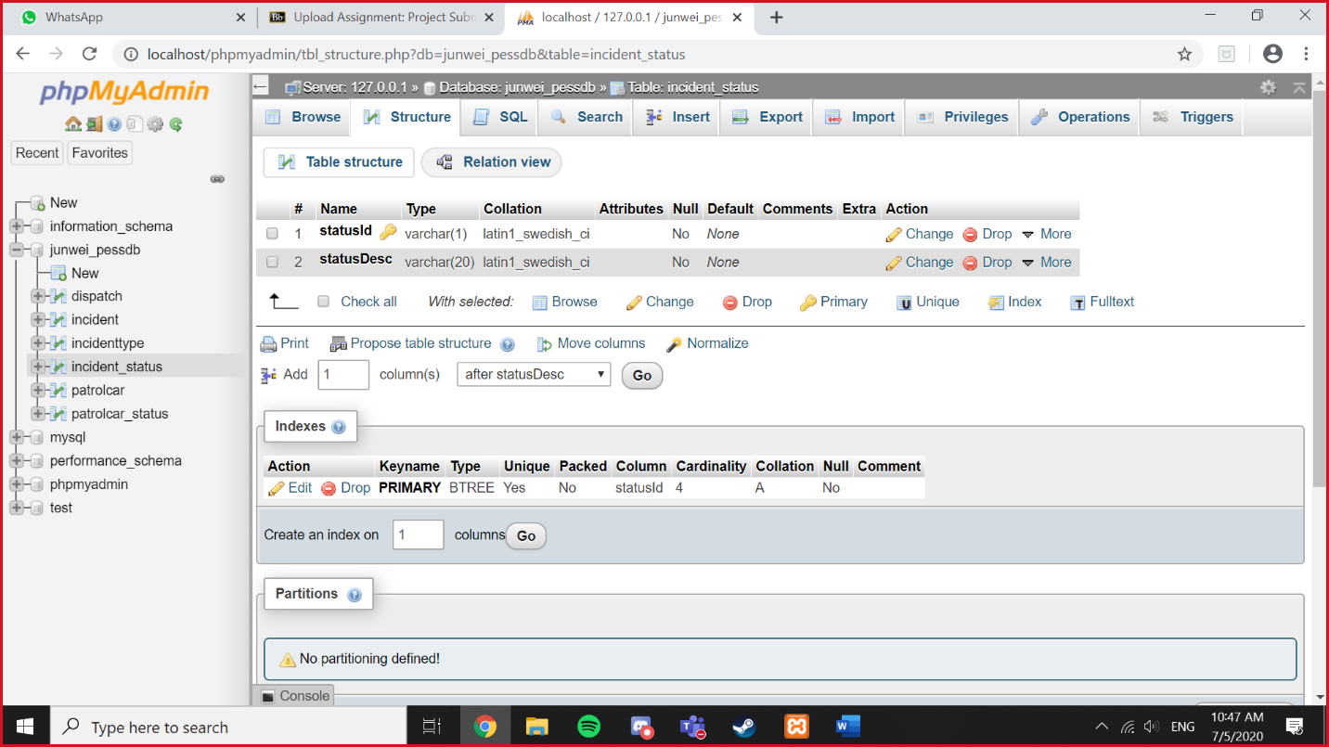Screenshot incident_status structure:

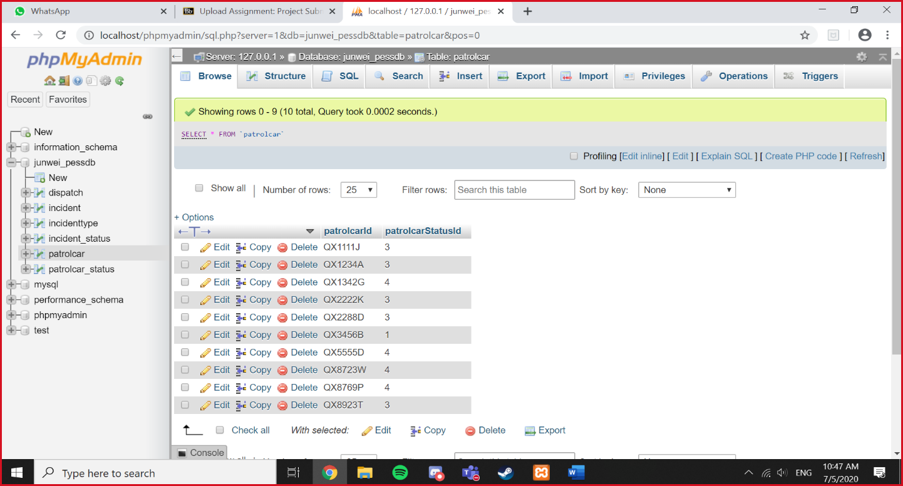Screenshot patrolcar browse:

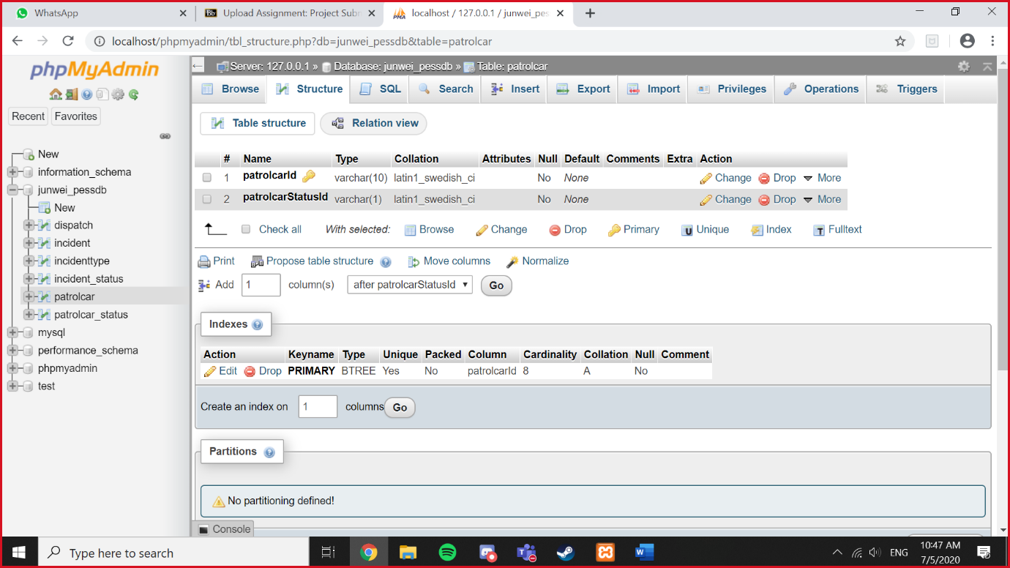Screenshot patrolcar structure:

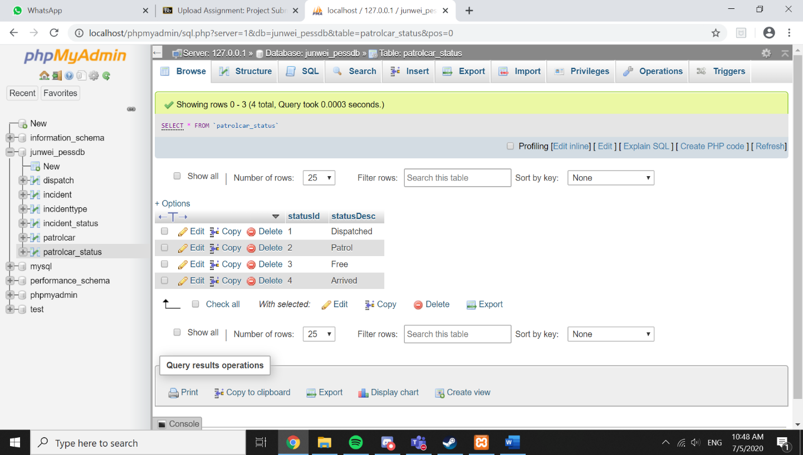Screenshot patrolcar_status browse:

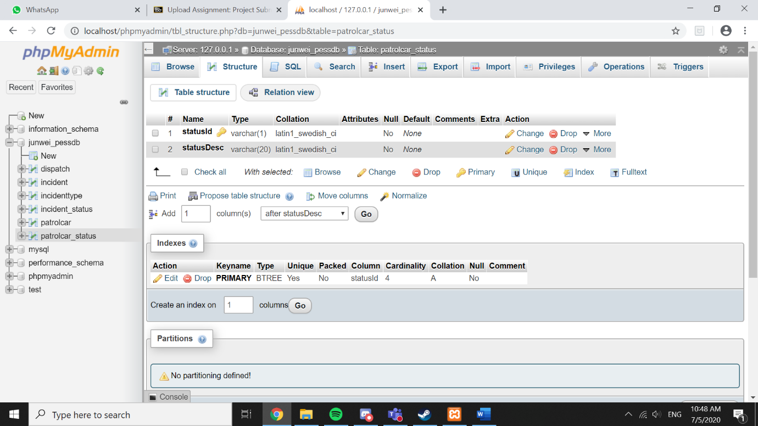Screenshot patrolcar_status structure:

**-END-**

Submission:

1. Remember to Export your yourname_pessdb
2. Put all your files in pessv1 folder: PSD file for banner, banner image file, Project part 1 Powerpoint, yourname_pessdb.sql, this screenshot word document, **ALL the PHP Files** and **CSS File**
3. ZIP your pessv1 and submit on my connexion
4. Upload pessv1 into Google Drive, share the link and whatsapp Mr Daniel